indochina hightlight TOUR FROM vietnam to cambodia
Routing: Hanoi - Ha Long Bay - Da Nang - Ba Na Hills- Hoi An- Phu Quoc- Ho Chi Minh city
Tour Style: Natural, Cultural & Historical Tour
Tour Start: in Hanoi / Tour End: in Ho Chi Minh city
Trip duration: 14 Days -13 Nights

Day | date | Trip Summary | Meals
01 |  | ARRIVAL IN HANOI – RICHSHAWS CYCLING TRIP | NONE
02 |  | HA NOI FULL DAY CITY TOUR: HISTORICAL & HERITAGE | B/L
03 |  | HANOI - TUAN CHAU MARINA - SET SAIL FOR HALONG BAY (SIC) | B/L/D
04 |  | MORNING IN HALONG BAY – BACK TO HA NOI- FLIGHT TO HO CHI MINH CITY | B/BR
05 |  | HO CHI MINH CITY TOUR- CU CHI TUNNELS | B/L
06 |  | HO CHI MINH CITY- MY THO- BEN TRE- CAN THO | B/L
07 |  | CAI RANG FLOATING MARKET- flight to phu quoc | B/L
08 |  | PHU QUOC – FREE BEACH LEISURE | B
09 |  | phu quoc- speed boat – cable car TOUR to hon thom | B/L
10 |  | VIN WONDER- GRAND WORLD RELAXING | B/D
11 |  | phu quoc- CONnECT flight to HO CHI MINH CITY & siem reap | B
12 |  | Siem reap- angkor temple tour | B
13 |  | siem reap- banteay srey- grand Circuit | B
14 |  | siem reap- tone sap lake boat trip– departure | B
Remarks: B = Breakfast | L = Lunch | D = Dinner | BR = Brunch | PVT = Private Tour | SIC = Seat-in-coach

Trip Details
DAY 1: ARRIVAL IN HANOI – RICHSHAWS CYCLING TRIP [meals: none]
Following your requested arrival time.
Upon arrival at Noi Bai International Airport, you will be greeted by our friendly driver and guide. We will then transfer to the central of Hanoi for check-in the hotel. Stay leisurely until being picked up for a Rickshaw Cycling Trip Around the Old Quarter.
The journey typically begins in the heart of the Old Quarter, where the narrow, winding streets are lined with colonial-era buildings, traditional shops, and local markets. As you settle into the comfortable seat of the rickshaw, the rider begins to pedal, and you're immediately drawn into the rhythm of Hanoi's daily life.
The rickshaw driver will take you back to your hotel, ending the first day full of joy. You will then have time on your own for dinner (your own accounts) and wandering around the town.
Overnight in Hanoi

DAY 2: HA NOI FULL DAY CITY TOUR: HISTORICAL & HERITAGE [meals: b/l]
8.00- 8.30: Get picked up by our friendly guide and start to explore Hanoi City
08.45: Arrive at Tran Quoc Pagoda located on Golden Fish IsLand in West Lake
It is the oldest pagoda in Ha Noi built in the 6th century.
09.30: Visit Ho Chi Minh complex, you have a chance to see the embalmed body of Ho Chi Minh then walk around the garden to see 2 houses where he lived & worked from 1954 to 1969. Then visit One Pillar Pagoda where worships the Godess of Mercy – It is the most unique padoga in the world
- Should dress modestly by covering from shoulders to knees when visiting Ho Chi Minh mausoleum, temples, pagodas…
- Ho Chi Minh’s Mausoleum is closed on Mondays and Fridays.
- Ho Chi Minh’s Mausoleum is closed at least 2 months (15thJune -15thAugust) for the annual maintaining but still can take picture Mausoleum and visit around that area
11.15: Visit Vietnam Ethnology Museum to learn about the culture of 54 ethnic groups living in the whole country of Vietnam
Special Note : we will visit Women Museum instead of Ethnology Museum closed on Mondays
12.45: Have lunch at our restaurant. You have an opportunity to enjoy Vietnamese cuisine
with 8 delicious dishes.
14.00-14.15 : Continue to visit Temple of Literature – the first university of Vietnam, established in the 11 century
15.15: Leave for Hoa Lo Prison Museum which originally used by the French colonists in Indochina for political prisoners, and later by North Vietnam for U.S. prisoners of war during the Vietnam War. During this later period, it was known to American POWs as the "Hanoi Hilton.
Then back to your hotel in Hanoi
Overnight in Hanoi
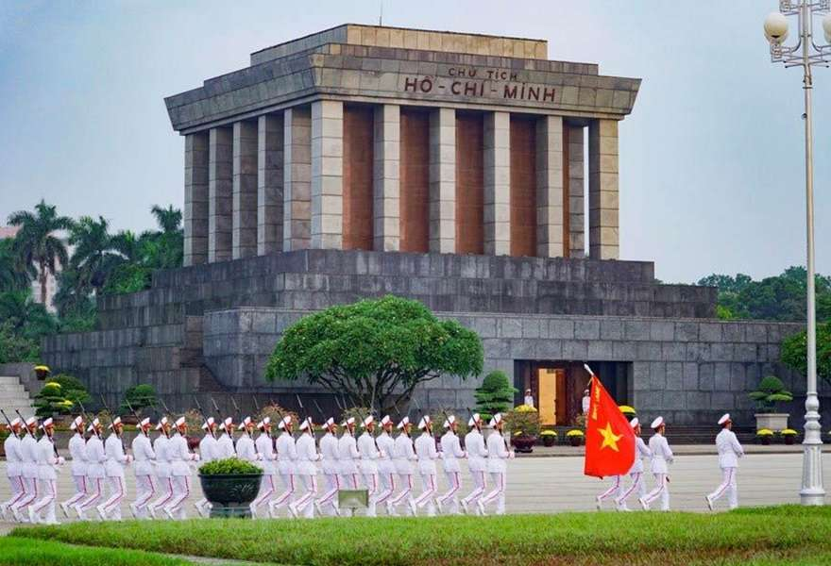 | 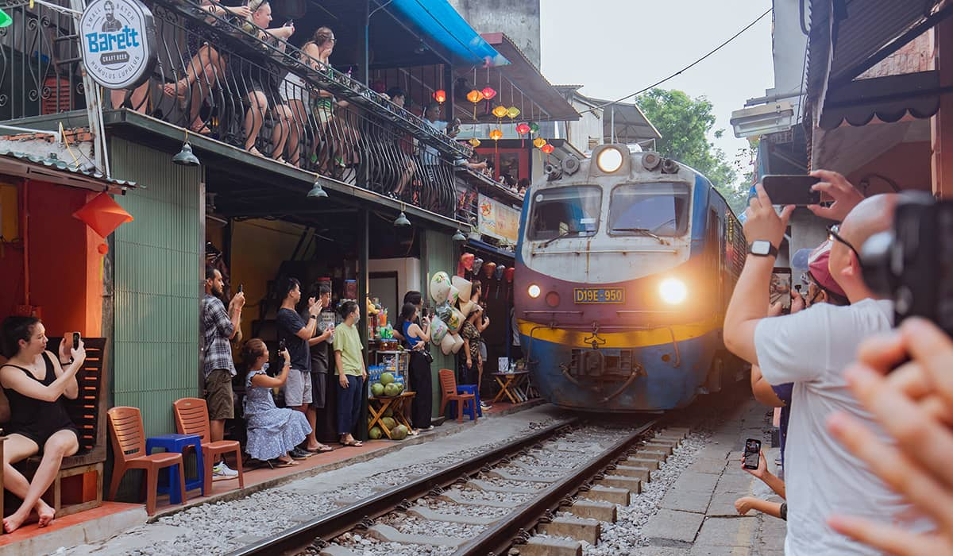

DAY 3: HANOI - TUAN CHAU MARINA - SET SAIL FOR HALONG BAY (SIC) [MEALS: b/l/d]
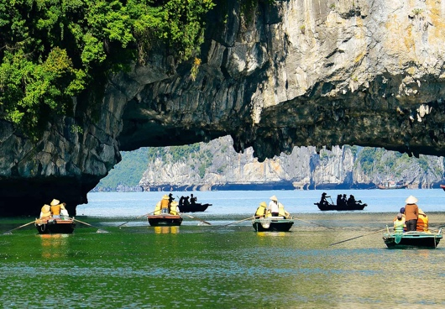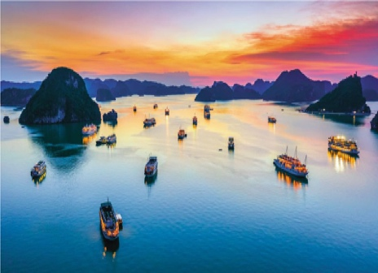
08:30 After breakfast, the shuttle bus will pick up at your hotel in Hanoi Old Quarter. Enjoy the landscape of the Red River Delta on the way to Ha Long Bay.
11:30 Arrive at Tuan Chau Marina, get checked in at the waiting lounge.
12:00 Embark on cruises, enjoy the welcome drinks while being given a short briefing. Check in to your room and get ready for a tasty lunch.
12:30 Enjoy Vietnamese and international lunch and the picturesque scenery of the bay, pass by the most beautiful areas: Incense Burner, Dog Stone Islet, Fighting Cock Islet, Three Coconuts Island.
15:00 Continue to explore Halong Bay by visiting Luon Cave. This is also an ideal place for kayaking, get up and close to the timeless beauty of Ha Long Bay.
16:30 Visit Titov Island - a small limestone island with one of the best sandy beaches in Ha Long Bay. You can immerse yourself in emerald water and hike to the top for stunning panoramic views of the bay.
17:30 Back to the boat and take part in a cooking demonstration on our sundeck, enjoy the bar’s Happy Hour (buy 01 get 01) program and watch the magnificent sunset over the bay.
(Option: Massage service available. Please book with Cruise Manager directly)
19:00 Deluxe dinner is served. Enjoy our traditional and fusion dishes prepared by our talented chefs.
21:00 After dinner it’s your time to enjoy at our bar and spa, fish squid or watch a movie in cabin, play cards, chess or relax on the sundeck.
Overnight in a quite Halong Bay Area.

DAY 4: MORNING IN HALONG BAY – BACK TO HA NOI- FLIGHT TO HO CHI MINH CITY [MEALS: b/br]
06:15 Seeing the bay in the morning is a wonderful experience, awaken all your senses with a Tai Chi session on the sundeck while gathering vitamin sea to refresh yourself before enjoying breakfast.
07:00 Coffee, tea and pastries for breakfast are served in the restaurant.
07:30 Visit Sung Sot Cave - a magnificent and largest limestone cave as its original name: Grotte des Surprising. The beautiful stalactites and stalagmites formed over millions of years are the reward after the steep climb on Bo Hon Island.
(*) Note: Proper shoes are highly recommended when it’s wet.
09:30 Back to the cruise ship. Check out and settle your bill at the reception.
10:00 Have brunch while cruising back. Relax on the sundeck or in the restaurant.
11:30 Disembark at Tuan Chau Marina. You will be met by our private driver. Then be transferred directly to Noi Bai International airport to depart to Ho Chi Minh
Upon arrival at Tan San Nhat Airport, you will be met by our driver. We will then transfer to your hotel in Ho Chi Minh city for relaxing or wandering around on your own.
Overnight Ho Chi Minh city.

DAY 5: HO CHI MINH CITY TOUR- CU CHI TUNNELS [MEALS: b/L]
Breakfast at your hotel.
Take the morning trip to visit Independence Palace, also known at the Reunification palace, was built on the sight of the former Norodom palace. The Independence palace is a widely known landmark of Ho Chi Minh City and was designed by the architect Ngo Viet Thu. Continue seeing the beautiful structures from the French Colonial times such as the Notre Dame Cathedral, the historic Central Post Office. Followed by the remarkable site of the War Remnants Museum the museum has a vast display of the both the Indochina wars.
Have lunch at local restaurant.
Depart for Cu Chi tunnel, the trip will take approximately one and a half hours bus driving. Upon arrival, before exploring the tunnels, you will have some short introduction followed by introductory video about how the tunnels were constructed and how the people survived in the harsh conditions of the war time. Then, spend your time to explore the remaining area and tunnel systems which included the special constructed living areas with kitchens, bedrooms side by side with other martial facilities like storage, weapons factories, field hospitals, and command centers helping whoever lives inside the tunnels meet their basic needs. Besides, there are also many hidden trap doors and dangerous traps within the maze-like tunnels for security purpose during the war. Afterward, special tea and cassava (guerilla’s food during the war) will be served.
Break time for relax or time for those who want to try the real shooting gun.
Return to Ho Chi Minh City
Overnight in Ho Chi Minh city
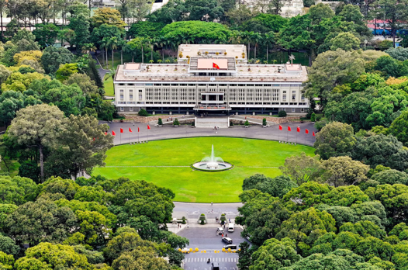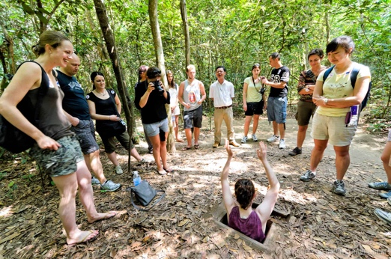

DAY 6: Ho Chi Minh city- MY THO- BEN TRE- can tho [MEALS: b/L]
Breakfast at your hotel then check-out properly.
Heading out of town, we travel by roads to the Mekong Delta. This plain region boasts the largest rice bowl of Vietnam. On the way, we will visit Vinh Trang pagoda, the biggest pagoda in the Mekong delta. Upon arrival in My Tho, we board a boat navigating around the intricate small canals, which is a great way to observe the local lifestyle close-up and catch a view dotted by many islands. The exciting river trip will pass by the lush green vegetation towards the famous Unicorn Island where we have a chance to stroll around an orchard, taste many seasonal fruits, see farmers at work and Vietnamese folk music performed by the local people. We navigate some narrower canals using small rowing boats to Ben Tre Province for an interesting visit to some local industries. The extra enjoyment is a lunch at one of the famous local eating spots. After lunch, enjoy your time relaxing, walking around the village, or perhaps going for a short bike ride.
Proceed to Can Tho City . Overnight in Can Tho
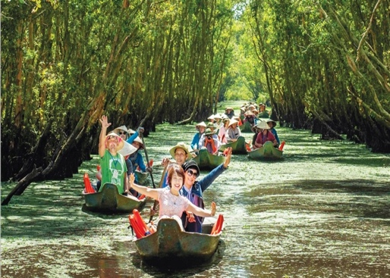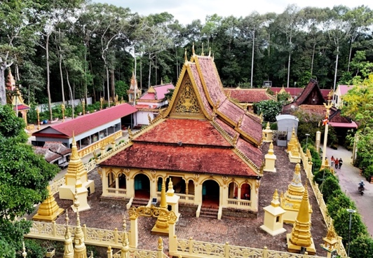

DAY 7: CAI RANG FLOATING MARKET- flight to phu quoc [MEALS: b]
Breakfast at your hotel then check-out properly.
Have breakfast at the hotel. Take a leisure boat trip to explore the picturesque tributaries of the Lower Mekong River (Bassac River) then visit to Cai Rang floating market which is the liveliest one in the whole of region. Take in the beautiful scenery and the daily activities of the locals who live along the Mekong canals. Enjoy fresh fruits on boat and walking trip to visit local noodle factory.
Then get transfer to Tan Son Nhat airport. Flight to Phu Quoc
On arrival in Phu Quoc. You will meet our driver then get private transfer to Hotel in Phu Quoc
Overnight in Phu Quoc

DAY 8: PHU QUOC – free beach leisure [MEALS: b]
After breakfast at your hotel your arre free leisure to discover Phu Quoc
Free leisure and overnight in Phu Quoc
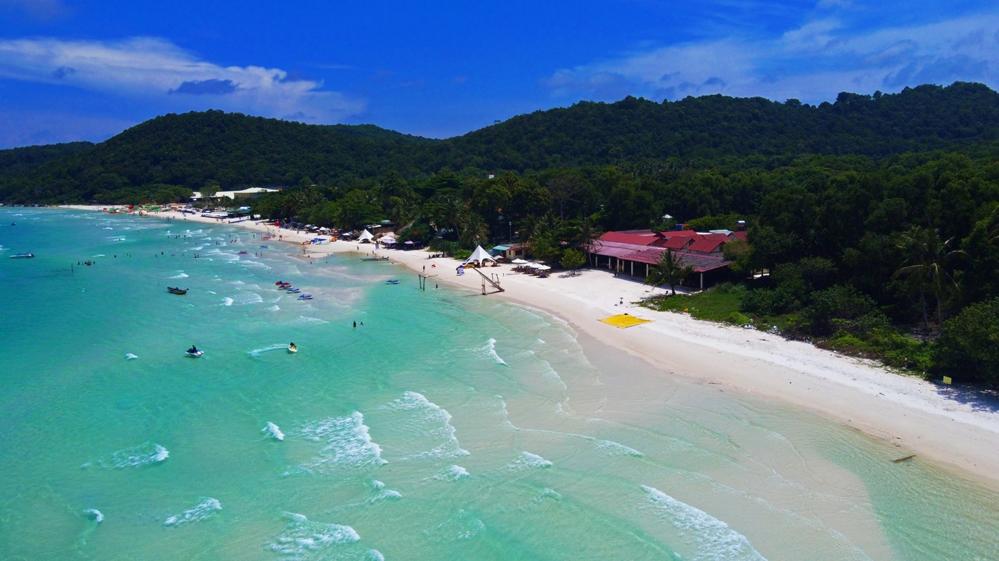

DAY 9: PHU QUOC- SPEED BOAT- CABLE CAR TO HON THOM- WATER PARK [MEALS: b/L]
Having breakfast at hotel.
Then Embark on an Island Speed Boat Tour from An Thoi port. This typically includes snorkeling or swimming at beautiful islands like Hon Roi, Hon Mong Tay, and Hon May Rut, known for their clear waters and vibrant coral reefs on your own. After the island hopping, you will head to the Sun World Hon Thom Cable Car station. Board the world's longest sea-crossing Cable Car to Hon Thom Island. The ride offers breathtaking aerial views of the archipelago. On Hon Thom, you'll have access to Sun World Hon Thom Nature Park, which includes Aquatopia Water Park and various beach activities
. 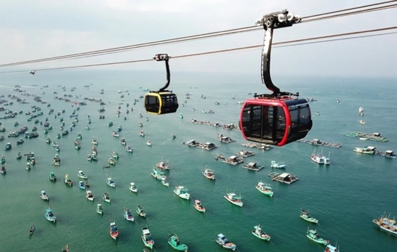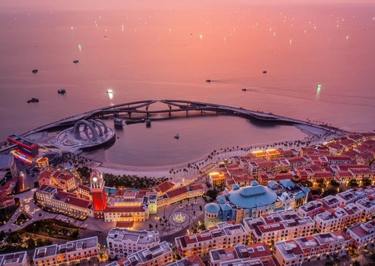
Late Afternoon Return via cable car to the mainland and proceed to Sunset Town (also known as Mediterranean Town). This beautifully designed area features European-inspired architecture, charming streets, and the iconic Kiss Bridge. As dusk settles, find a good spot to witness the spectacular sunset.
Then we go back to hotel for relaxing !
Overnight in Phu Quoc

DAY 10: VIN WONDER- grand world [MEALS: b/d]
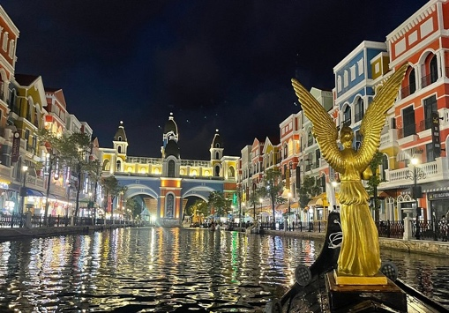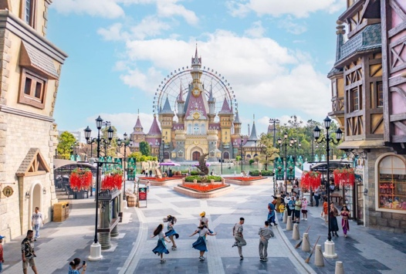
The car will pick you up at the hotel and depart for VinWonders Phu Quoc - the first and largest theme park in Vietnam. The tour guide will pick you up at the gate and accompany you throughout the journey. (no guide)
Conquer the thrilling game area , cool off at the modern water park , explore the central castle , step into the fairy tale world and visit the unique Viking village .
Visit Neptune Palace - an underground aquarium, home to thousands of marine creatures and stunning mermaid shows.
Enjoy the spectacular Once show with stunning sound and light effects
15:30 – 22:15 : Arrive at Grand World and start your journey to explore the “City that never sleeps” with famous spots:
Visit the Vietnam Quintessence area , enjoy Vietnamese cuisine & watch the Nha Tich Thanh Hoang show, Sunset Beach Bar: Watch the sunset & enjoy live music
Enjoy dinner with Kien - Xay specialty Bun Quay, Visit the Teddy Bear Museum
Watch the big show Tinh Hoa Viet Nam (at your own expense)
Enjoy drinks, watch Grand World at night and watch the water music show "Colors of Venice ".
22:15 – 23:00 : Car takes you back to the hotel and ends the exciting journey.
Free leisure and overnight in Phu Quoc

DAY 11: phu quoc- connect flight to ho chi minh city & siem reap [MEALS: b]
Breakfast at your hotel then check-out properly.
Then you will get transfer to Phu Quoc Airport for your flight to Ho Chi Minh City, where you’ll connect to an international flight bound for Siem Reap, Cambodia — the gateway to the legendary temples of Angkor. Upon arrival at Siem Reap International Airport, you’ll be warmly greeted by our local transferred to your hotel for check-in. Take some time to relax after your journey. Overnight in Siem Reap

DAY 12: Siem reap- angkor temple tour [MEALS: b]
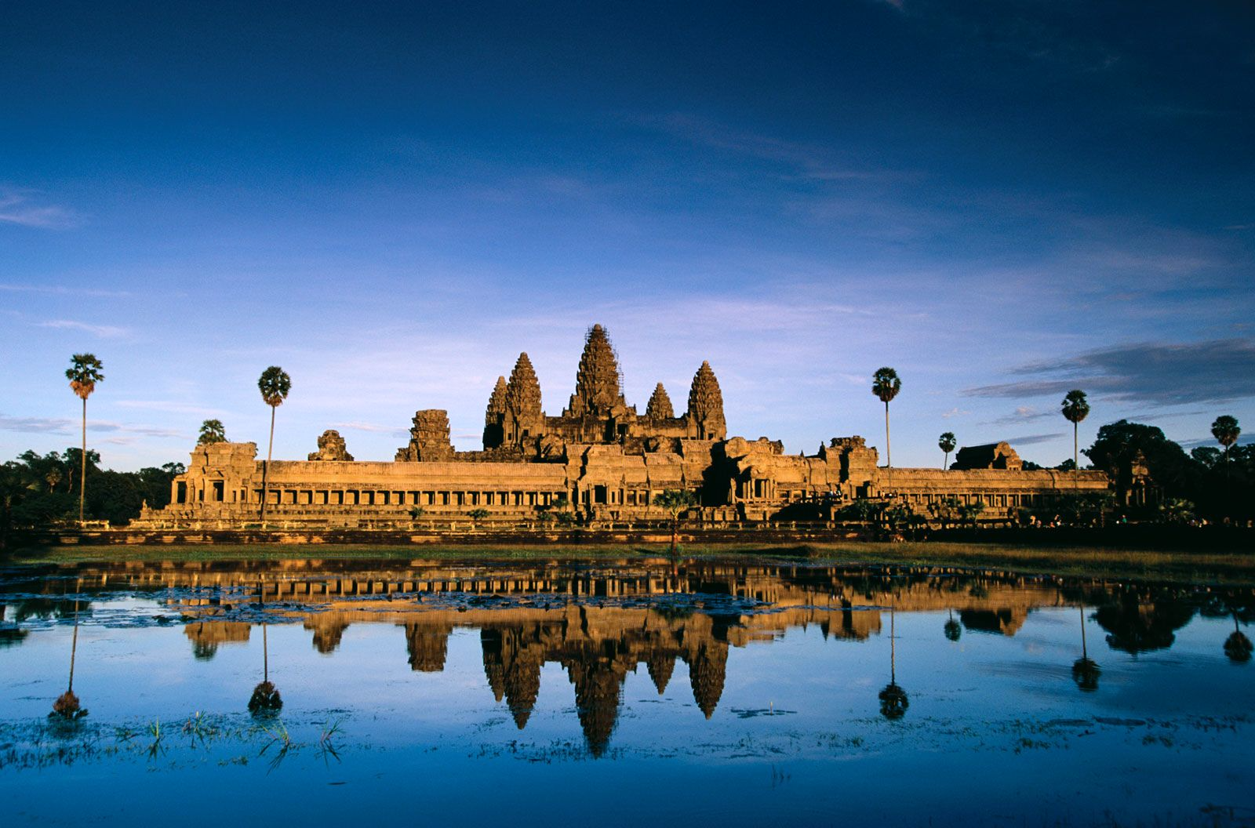
Breakfast at your hotel.
The take a trip to Visit the antique capital of Angkor Thom (12 century): the South Gate with its huge statues depicting the churning of the ocean of milk, the Bayon Temple, unique for its 54 towers decorated with over 200 smiling faces of Avolokitesvara, the Phimeanakas, the Royal Enclosure, the Elephants Terrace, the Terrace of the Leper King, and
Ta Prohm, one of the area’s most beautiful temples. Ta Prohm has been relatively untouched since it was discovered and retains much of its mystery.
Lunch not included
Visit to the most famous of all the temples on the plain of Angkor: Angkor Wat. The temple complex covers 81 hectares and is comparable in size to the Imperial Palace in Beijing. Its distinctive five towers are emblazoned on the Cambodian flag and the 12th century masterpiece is considered by art historians to be the prime example of classical Khmer art and architecture. Enjoy wonderful sunset from the top of Pre Rup temple
Overnight in Siem reap

DAY 13: siem reap- banteay srey- grand Circuit [MEALS: b]
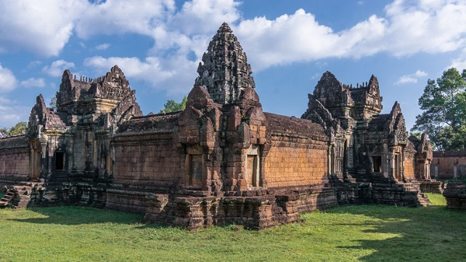
Breakfast at your hotely.
Visit to Banteay Srey, known as Citadel of Women or a Pink Temple, and Banteay Samre Temples
Lunch not included
Visit to the unique interior brick sculptures of Prasat Kravan, Srah Srang ("The Royal Baths" was once used or ritual bathing), Banteay Kdei (surrounded by 4 concentric walls), Neak Pean, a fountain built in the middle of a pool (representing the paradisiacal Himalayan mountain-lake) and Preah Khan temple, Built by the King Jayavarman VII. Preah Khan is, like Ta Prohm, a place of towered enclosures and shoulder hugging corridors. Unlike Ta Prohm, however, the temple of Preah Khan is in a reasonable state of preservation and ongoing restoration efforts should maintain and even improve this situation.
Overnight in Siem Reap

DAY 14 siem reap- tone sap lake boat trip– departure [MEALS: b]
Breakfast at your hotel
In the morning, we will enjoy a boat ride on the Tonle Sap Lake at KAMPONG PHLUK VILLAGE. This is the largest permanent fresh-water lake in South East Asia and flows into Tonle Sap River, joining the Mekong in Phnom Penh. We will see a fishermen's "floating village" with floating schools, floating police station, etc. It is same as a big village floating on the lake, and the "village" move from place to place following water levels and current.
Lunch not included
Transfer to Siem Reap airport for flight to next destination

End of Services!
***********************************************

WITH VIETLONG TRAVEL OFFER FOR HIGH TOURISM SEASON

Description | Adults (>11 years old)
 | 2 | 3-6 | 7-10 | 11-15 | 16-20 | Single Supplement
 | Twin/Double/ Triple Shared Room
Category 3* |  |  |  | $365 |  | $195
Category 4* |  |  |  | $465 |  | $250
Category 5* |  |  |  | $618 |  | $450

INCLUSIVE OF ABOVE PROGRAM:
- ACCOMMODATION (Double sharing occupancy) with daily breakfast (Check-in/Check-out time around noon).
- EXPERIENCED ENGLISH SPECKING TOUR GUIDE for ALL TOURS.
- Services of a driver and private air-conditioned vehicle for all airport transfers.
- meals as mentioned on program
- 1 Day trip discover Hanoi city
- 2 Way private bus transfer Hanoi- Ha Long bay
- 2 Days 1night trip to Ha Long Bay with overnight on
- Round trip with cable car and buffet lunch in Phu Quoc
- Basket boat and Floating lantern boat activities in Hoi An
- Water park ticket in Hon Thom
- Ticket for Grand world, Vin wonder and Grand World
- Half- day city tour discover Ho Chi Minh city
- Boat trip in Mekong Delta and Tonle Sap Lake
- Government taxs

EXCLUSIVE OF ABOVE PROGRAM:
- Round-trip international flight from your country, Domestic flight tickets.
- Early check in or late check out service
- Visa - as per country requirements.
- Travel insurance (we highly recommend that you purchase adequate insurance).
- Additional meals/beverages and personal expenses.
- Offering tips and expressing gratitude for guides and drivers is recommended at a rate of 5 USD /client /day for guides and 2 USD per client /day for drivers. Feel free to adjust the amount based on your satisfaction with their services.

